
A10
Sreenidhi Institute of Science and Technology
(An Autonomous Institution)
Code No: 111EM01
B. TECH. II-Year I-Semester Examinations, December 2015 (Supplementary)
DISCRETE STRUCTURES AND GRAPH THEORY (ECM)

Time: 3 Hours Max. Marks: 70

Note: No additional answer sheets will be provided.

Part - A
Max.Marks:20

Answer all QUESTIONS. EACH QUESTION CARRIES 2 MARKS.
1. What is Euler’s ф function?
2. What is Hamiltonian graph?
3. Give an example for Group
- ~ (P→ Q) ⇔
a) P∧Q b) ~ P∧~Q c) P∧~Q d) ~P∧Q
5. A relation R in X is said to be a compatibility relation if it is
a) Reflexive b) Symmetric c) Both a&b d) none of the above
6. Define Universal Specification and Existential Specification.
7. In P → Q, P is called as ……………..and Q is called as ………………..
8. What is Recurrence relation?
9. Define the following a) semi group b) a sub graph.
10. The number of edges in a complete graph with 4 vertices _______

Part – B
Max.Marks:50

ANSWER ANY FIVE QUESTIONS. EACH QUESTION CARRIES 10 MARKS.

- (a) Show that the set "N" is a monoid with respect to multiplication. [3+3+4]

(b) Let A = {2, 3, 5, 30, 60, 120, 180, 360}. Draw the Hasse diagram for the poset [A ; |].

(c) Find the complement of the lattice obtained by the Hasse diagram for poset [D₃₀; |].

- a) Obtain the formulae having the simplest possible form which are equivalent to formulae given below:
i. (P→Q) ↔ (~ Q →~P)˄ R 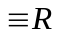
ii. (P ˄(Q ˄ S)) V (~P ˄( Q ˄ S)) ( Q ˄ S)

b) Obtain the principal disjunction and conjunction normal form for the following
i. (~P V~ Q) → ( P ↔ ~ Q)
ii. Q∧ (P∨~Q)

3. a) Use the technique of backtracking, to find an explicit formula for the sequence defined by the recurrence relation and initial condition for a_{n}= 5a_{n-1}+ 3, a₁= 3.
b) Solve the recurrence relation a_{n} = -6a_{n-1} – 9a_{n-2}, a₁ = 2.5, a₂ = 4.7 by characteristics roots

- Are the following conclusions valid forms the premises given? Justify your answer.
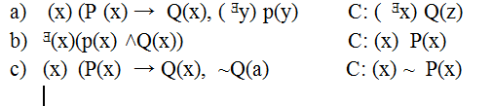

5. a) In the expansion of (x₁ + x₂ + x₃ +x₄ +x₅)¹⁰
Evaluate the coefficient of x₁² x₃ x₄³ x₅⁴
b) In the expansion of (2x – 3y + 5z )8
Evaluate the coefficient of x3 y3 z²

6. Write notes on the following: [3+3+4]
a) Free and Bound variables
b) Recursive Functions
c) Connectivities

7. a) What are the steps involved in graph traversal using Breadth first search
algorithm? Illustrate with a graph example.
b) What is the planar graph? Explain with an example.

8. What are the steps involved in determining whether two given graphs are
isomorphic or not?

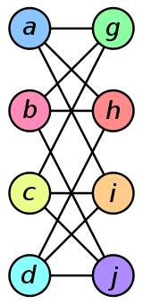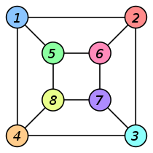

-- 00 -- 00 --

